National University of Computer and Emerging Sciences



Lab Manual # 03
Digital Logic Design (EL1005)

Course Instructor | Mr. Haris Jamil
Lab Instructor(s) | Mr. ZummarSaad  Mr. Muhammad Salman Mubarik
Section | BDS-2A
Semester | Spring 2022

Department of Computer Science
FAST-NU, Lahore, Pakistan

In Lab Statement:
Operation of AND gate according to its truth table
Install IC (integrated circuit) for AND (74LS08) on the breadboard according to the connection diagram given below.

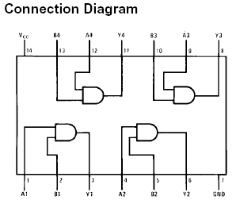

Operation of OR gate according to its truth table

Install IC (integrated circuit) for OR (74LS32) on the breadboard according to the connection diagram given below.
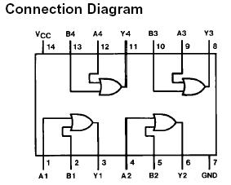

Operation of NOT gate according to its truth table

Install IC (integrated circuit) for NOT (74LS04) on the breadboard according to the connection diagram given below.

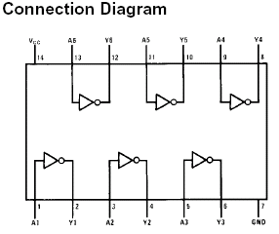

Question # 1:

Find Max terms from the following Min terms

F(X,Y,Z) =Σm(0,1,3,6,7)

- Write the expression for POS
- The numeric values as: Π M = ________
- Implement the max terms expression (part a) on Trainer and logic works.

Question # 2:

From the following truth table, “F” represents the output.
- Write the sum of min terms expression.
- Write product of max terms expression.
- Implement part (a) on Trainer and Logic Works.

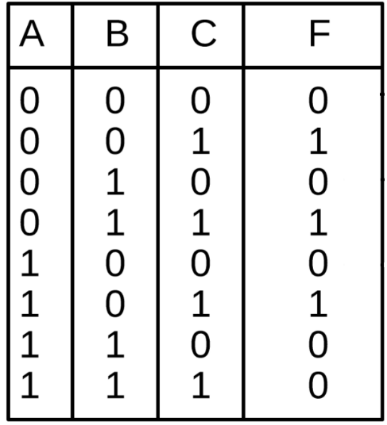

Question # 3:
Convert the following expressions into SPOS and implement the final expression on Trainer and Logic Works.

(A’+B+C’) . (A+C’)

Question # 4:

For the Boolean function $F1(A,B,C)=\sum{m(0,2,5,6,7)}$ do the following:
- Find truth table

- Find minimal SOP expression for Boolean function $F1$.

- Fill the following table and implement the circuit

IC type | Required No. of Gates | Gates per IC | Required No. of ICs
Total no. of ICs

